Tools Used:

|  |  |  |
| --- | --- | --- |
| # | Tools Used | Version Compatible |
| 1 | Visual Studio Community 2017 for Mac | 7.5.3 |
| 2 | Nunit Framework | 2.6.3 |
| 3 | Selenium Webdriver | 3.13.1 |
| 4 | Selenium Webdriver Chrome | 2.40 |
| 5 | Selenium Web Driver FireFox | 0.21.0 |
| 6 | Chrome Server | Latest |
| 7 | FireFox Gecko Driver | Latest |
| 8 | Chrome Broswer | 67.0 (MAC) |
| 9 | FireFox Quantum Browser | 61.0.1 (Mac) |
| 10 | .NET Framework | 4.7 |

Project Structure

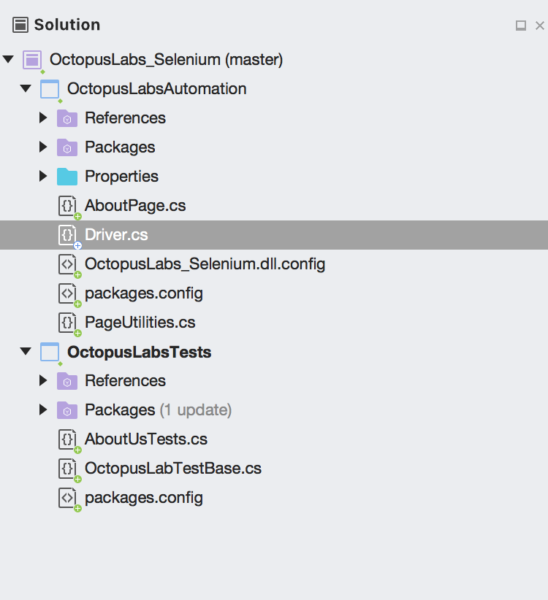

Project :

1 - Octopus Labs Test – Test Case Projects

2 – Octopus Labs Automation – Automation Code with Selenium